NEED FINDING ASSIGNMENT

John Paul C. Villanueva

Raymond Anthony A. Villaflores II

Bus Arrival Interval / Waiting time

**Introduction**

The general populace in Manila travel from place to place using public transportation, such as jeepney, busses, tricycle, taxi cabs or motorcycles. One of the busiest areas that most of these public transportations use is the EDSA. EDSA is prominently the busiest avenue with a lot of commuters. Commuters use bus terminals and bus stops to ride and alight in different points along EDSA. A typical bus arrives around 10-15 mins depending on the traffic flow, and commuters will have to wait that long. Time is essential for everyone, as it cannot be taken back.

**Statement of the Problem**

Commuters tend to wait on a bus stop or terminal, either early or late, due to overcrowding. With no available bus, no available seats, commuting proves to be challenging. Overcrowding is also a case, making it difficult to ride with lots of passengers racing to take that comfortable seat.

**Observation**

**Initial Observation: Pre-Paper Prototype**

During the interviewers’ observation, they provided 4 simple questions for commuters to answer which stresses on waiting time and their activities

1. How long do you usually wait for a bus to arrive, rush hour and off-peak?

2. How long do you take reaching the nearest bus stop or terminal by walking?

3. Would you like to reach the bus stop or terminal with a bus already waiting or ready for loading? Why?

4. do you often have anything else you wanted to do while waiting for the bus? example, buy food or drinks, you forgot something at home/office

Commuter #1 – Male, Student

1. Rush hour is 20 minutes tops. Peak/Off would be 15 – 20 minutes.
2. 2 minutes.
3. Yes, because I could get a seat for my own.
4. Foods and drinks

Commuter #2 – Female, Working

1. 30 mins to 1 hour during rush hour. Off peak is 30 mins
2. From Pasay Tramo to LRT Buendia, around 15 minutes walking
3. No, I just wait in the highway until the bus comes
4. Just checking my bag if I got everything I need

Commuter #3 – Male, Working

1. 30 mins to 45 mins.
2. 1 hour.
3. I would like the bus stop with the bus already waiting so that I can have a seat, whenever it will be waiting for its time to depart the station.
4. No, there is none.

**User Needs**

Commuters main concern is seat availability, or a guaranteed spot on the bus. They also need to know the exact time when the bus will arrive and leave, to plan their schedule. Aside from that, commuters also need to know if they can get a ride on the bus, so if they couldn’t, they could take other options.

**Point of View**

* Availability is Necessary
* Standing is fine but sitting down is better

**Wireframes and Screens**

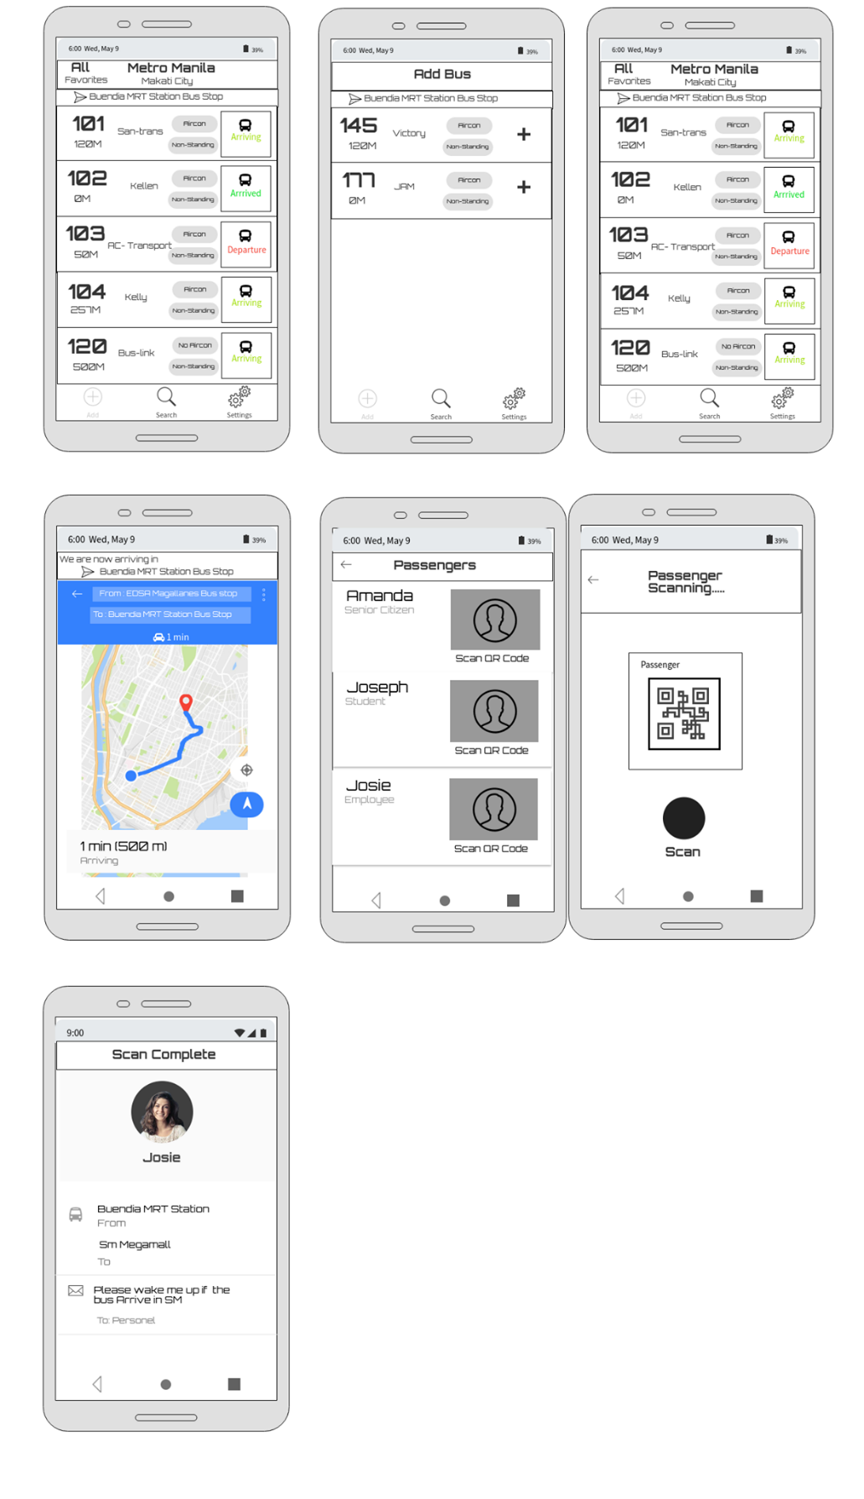

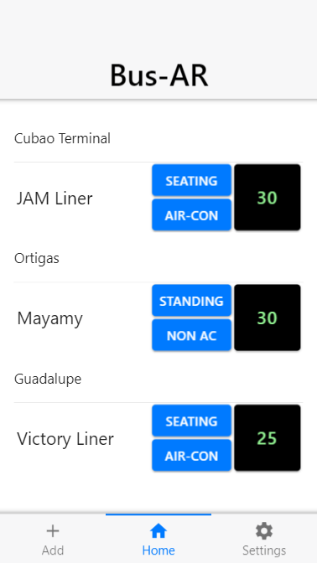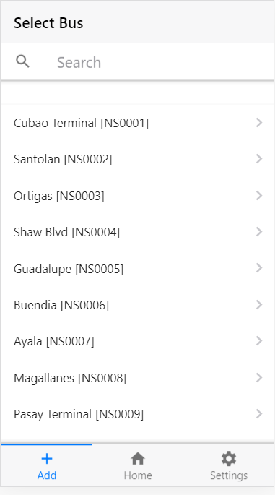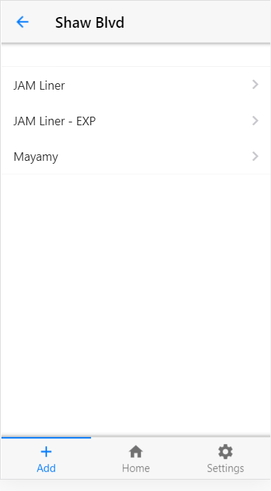

**Feedback and Suggestions**

**Commuter #1**

Kevin Rianzares

* “Suggestion kung ano yung mga terminal nearby, marami pang vacant para masmabilis macheck ng user”

**Commuter #2**

Jhed Bunagan

* “As a commuter, masmagiging maayos naman, masmapapadali yung oras gamitin. Ma-oorganized mo pa kung may gagawin ka pa sa ganitong oras”
* Concerned on exact time when the bus will arrive.
* Concerned on knowing which bus is the one booked.
* “Magiging convenient sa pasahero”

Taking the feedback and suggestions, we summarize that one important thing is to know specifics. Such as knowing the exact location of bus, knowing when it will arrive, knowing which bus is the one reserved. As well as the specifics of nearby bus stops.